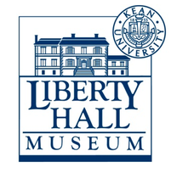
Liberty Hall Museum Word Search:
American Revolution
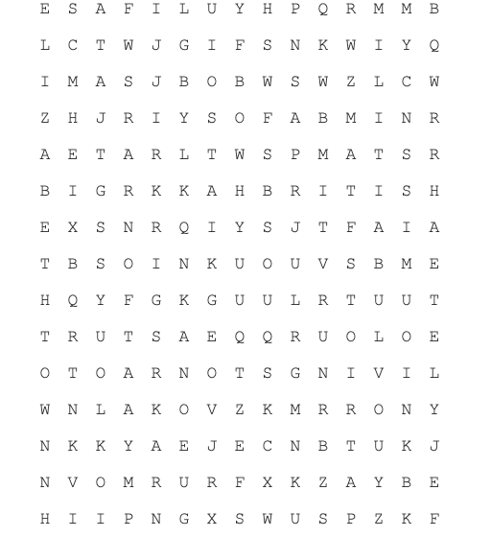

Patriot Yorktown

British King

Loyalists Elizabethtown

Quakers Sugar

Washington Tea

Livingston Stamp

Militia

