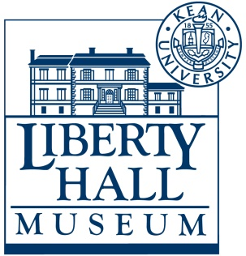
Liberty Hall Museum
Word Search:
Liberty Hall as a Museum

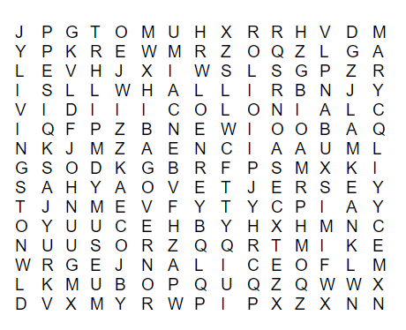

WILLIAM

LIVINGSTON

JOHN

KEAN

MARY

ALICE

NEW

JERSEY

LIBERTY

HALL

MUSEUM

URSINO

GOVERNOR

COLONIAL

ELIZABETHTOWN

